Test Case: tc002_SPX_Dev5_Crear_Requisicion_Spot_Tipo_Cobro_Project
Step 1 - Enter username and password and click to button Enter: Credentials Entered
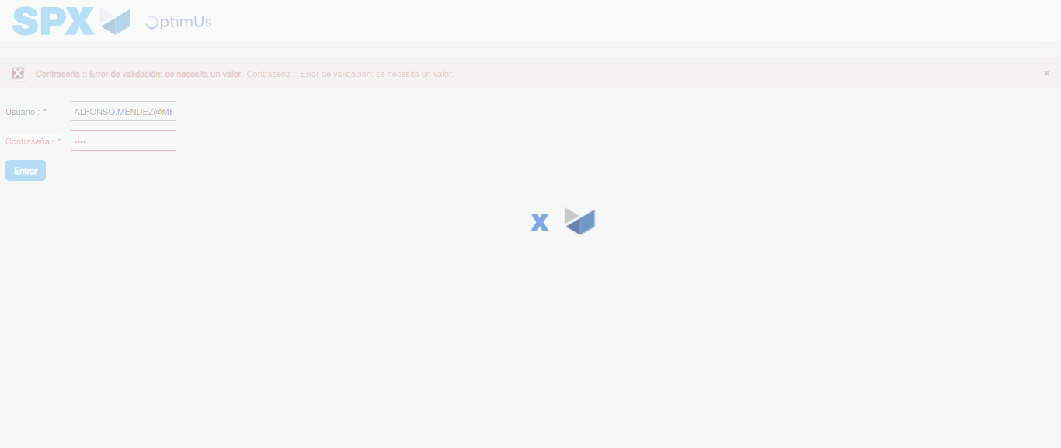Image file-name: QC_Testing-tc002_SPX_Dev5_Crear_Requisicion_Spot_Tipo_Cobro_Project-1783381981020

Step 2 - Select to UEN and Access to Spot Buy Requisitions : UEN Correctly selected and Correct access
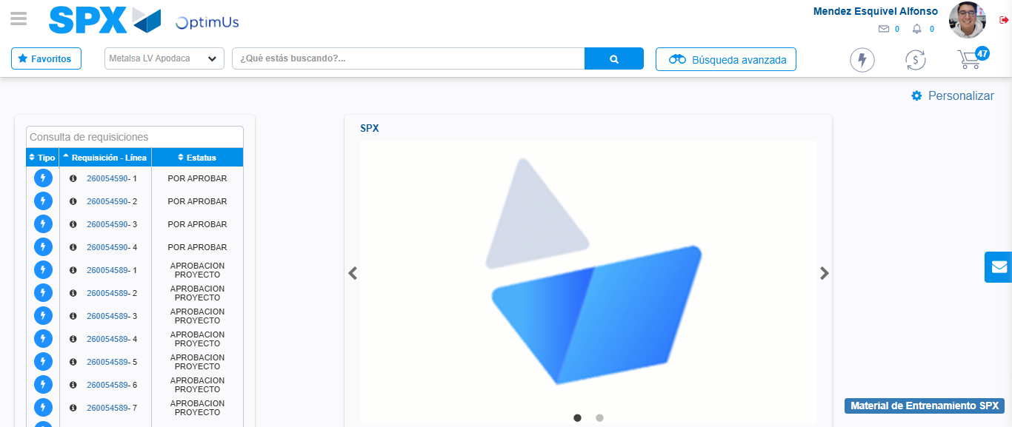Image file-name: QC_Testing-tc002_SPX_Dev5_Crear_Requisicion_Spot_Tipo_Cobro_Project-1783382006220

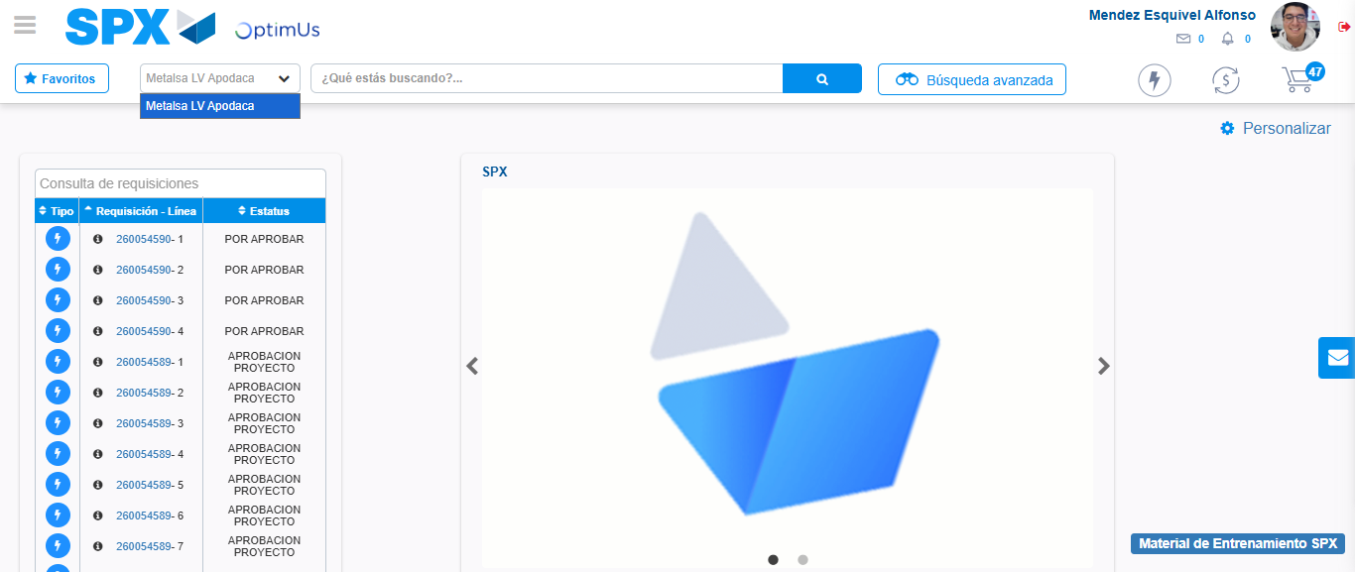Image file-name: QC_Testing-tc002_SPX_Dev5_Crear_Requisicion_Spot_Tipo_Cobro_Project-1783382008724

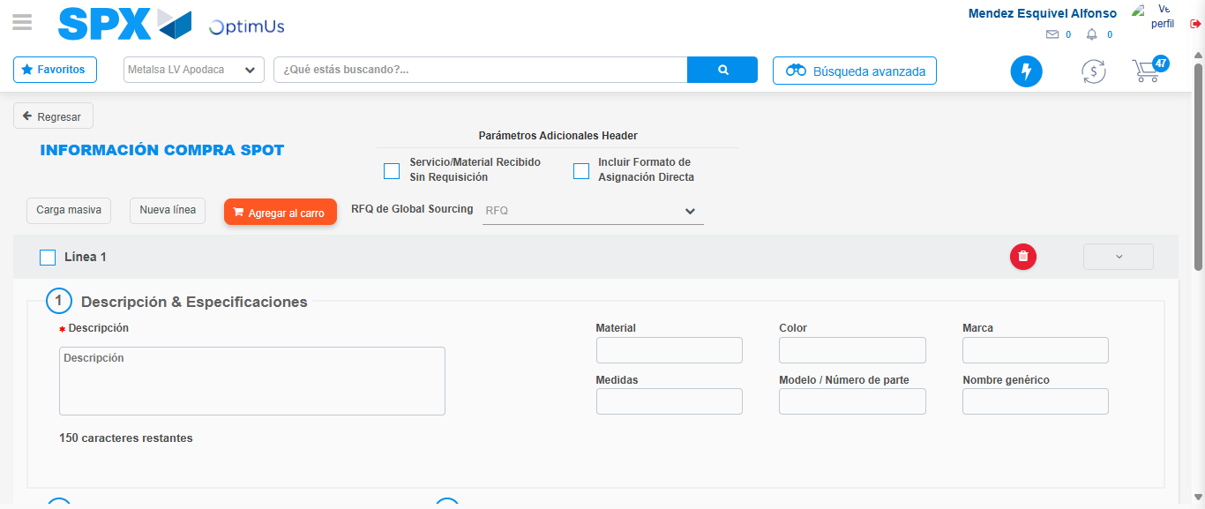Image file-name: QC_Testing-tc002_SPX_Dev5_Crear_Requisicion_Spot_Tipo_Cobro_Project-1783382033567

Step 3 - Data Capture Spot Buy Requisition: Data captured correctly
Image file-name: QC_Testing-tc002_SPX_Dev5_Crear_Requisicion_Spot_Tipo_Cobro_Project-1783382033850

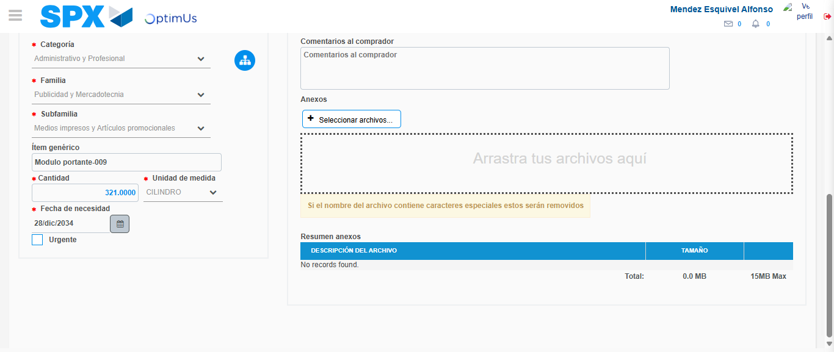Image file-name: QC_Testing-tc002_SPX_Dev5_Crear_Requisicion_Spot_Tipo_Cobro_Project-1783382043416

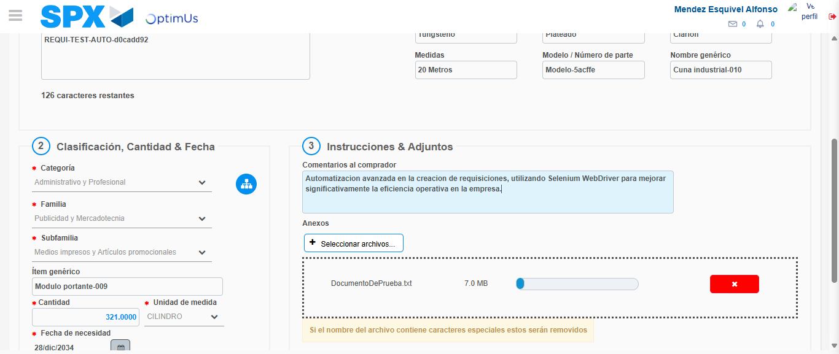Image file-name: QC_Testing-tc002_SPX_Dev5_Crear_Requisicion_Spot_Tipo_Cobro_Project-1783382044184

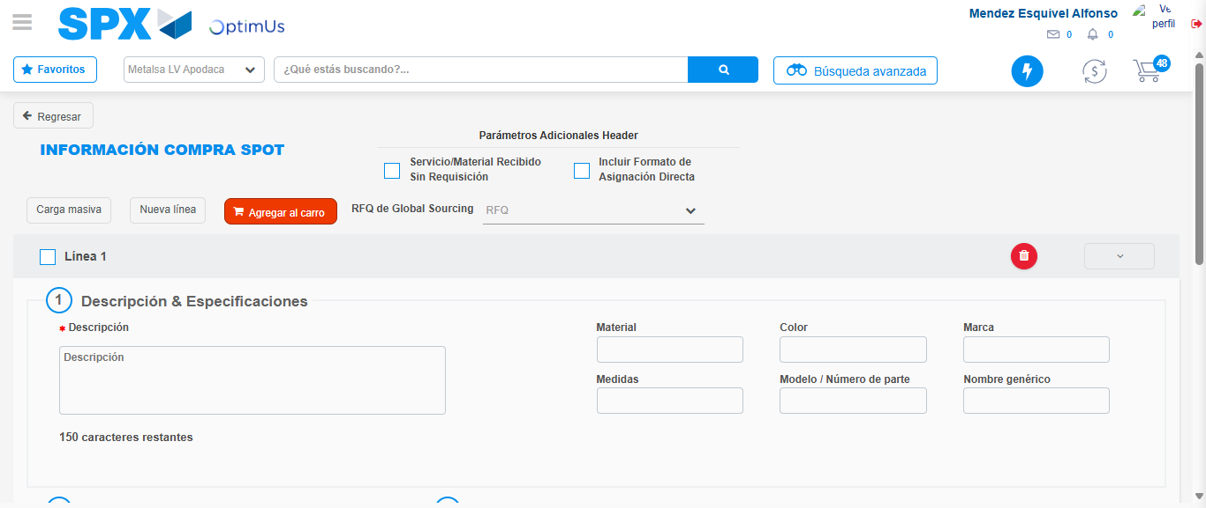Image file-name: QC_Testing-tc002_SPX_Dev5_Crear_Requisicion_Spot_Tipo_Cobro_Project-1783382051567

Step 7 - Return to Main Page SPX : Return to Main Page SPX
Image file-name: QC_Testing-tc002_SPX_Dev5_Crear_Requisicion_Spot_Tipo_Cobro_Project-1783382006220

Image file-name: QC_Testing-tc002_SPX_Dev5_Crear_Requisicion_Spot_Tipo_Cobro_Project-1783382008724

Image file-name: QC_Testing-tc002_SPX_Dev5_Crear_Requisicion_Spot_Tipo_Cobro_Project-1783382033567

Image file-name: QC_Testing-tc002_SPX_Dev5_Crear_Requisicion_Spot_Tipo_Cobro_Project-1783382053818

Image file-name: QC_Testing-tc002_SPX_Dev5_Crear_Requisicion_Spot_Tipo_Cobro_Project-1783382054033

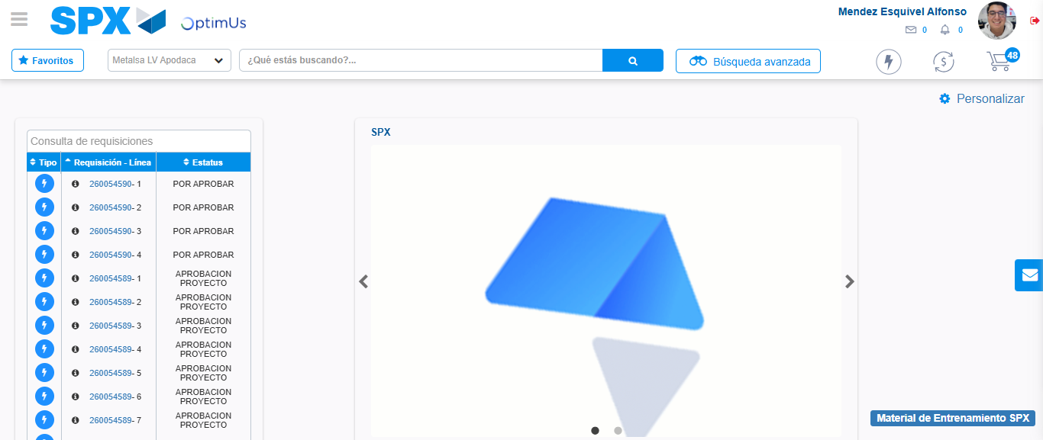Image file-name: QC_Testing-tc002_SPX_Dev5_Crear_Requisicion_Spot_Tipo_Cobro_Project-1783382075154

Step 8 - Log Out : Log Out SPX
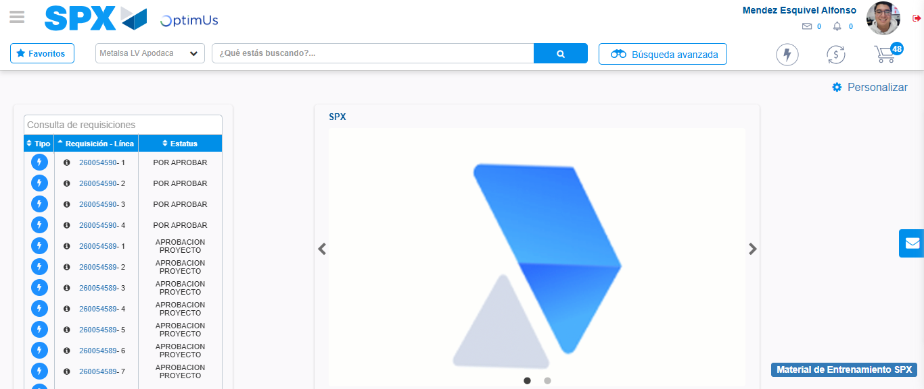Image file-name: QC_Testing-tc002_SPX_Dev5_Crear_Requisicion_Spot_Tipo_Cobro_Project-1783382075409

